**Selection and Baseline Creation**

For this assignment I am going to do the Comparative UX Analysis project idea and compare the food delivery apps Wolt and Uber Eats. I am only going to compare a few parts of the app since comparing the entire app would be too big for the scope of this project. Wolt is popular in Europe, while Uber Eats is popular in America. This also might have some impact on the choices each company made, since there is a different user profile needed.

Some of the criteria I am going to compare are

* the usability of the app, and how easy it is from set up to use.
* How visibly pleasing the colors and aesthetic is.
* How is the content organized
* Order tracking

To do this I am rate these 4 criteria based on a 1-5 scale where 1 is poor and 5 is perfect. I think that since both are big companies in big markets, I would think that almost everything will be 4s and 5s due to the fact they have lots of user interactions along with professional UX/UI designers for the app, and since they have lots of customer also probably get a lot of feedback on their apps.

|  |  |  |  |  |
| --- | --- | --- | --- | --- |
| Criteria | Task | Wolt | Uber | Notes |
| Usability | Find and order a burger from a local restaurant | 5 | 5 | Both are easy to use and give good suggestions |
| Visual Design | How does the app feel when using it | 5 | 5 | Both are aesthetically pleasing and both have fast response times |
| Organization | How are they organized | 4 | 4 | Both have very similar designs |
| Order Tracking | Features during the order tracking phase. | 5 | 5 | Both have driver ETA, location and a map to see the driver on the map |

**Analysis**

Uber Eats - Some of the strengths are that it is simple to use. There are lots of filters, but not too many buttons to be overwhelmed. It is easy to find a place to get food from and easy to find a new place to get food from. Some of the weaknesses of the app is that there is a lot of images and that might make it hard for you to find the specific button to choose. For example, on the search menu.

Wolt – Also simple and easy to use. As soon as you open the app you have many options to choose from. The blue and black is a great color scheme. Some of the weaknesses can be found on the home screen with the moving ad right in the middle of the screen. Sometimes it has food recommendations, but it also advertises Wolt+ along with any other specials going on. I bet it is good for advertising but can be distracting.

**Comparison and Synthesis**

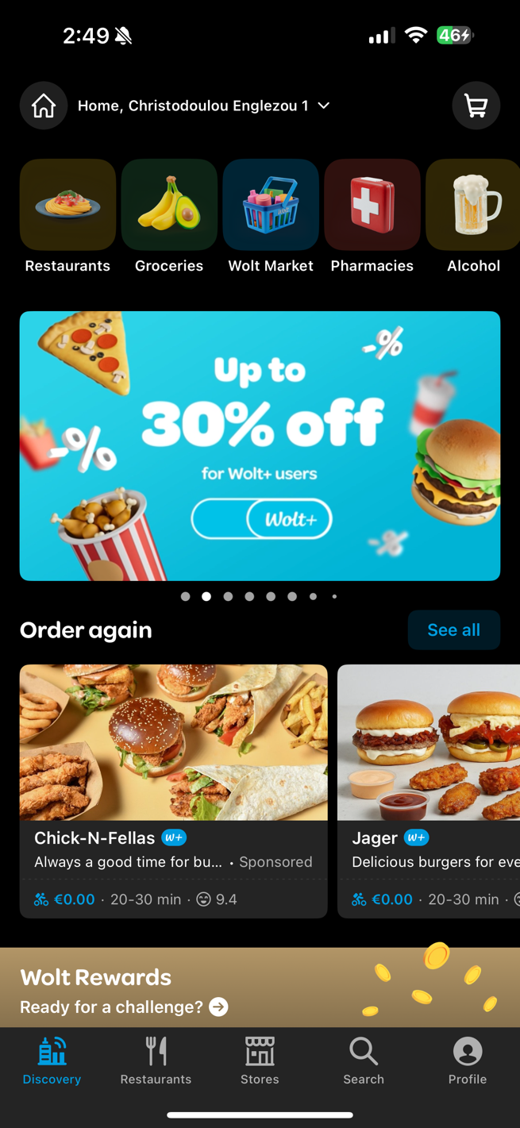

The home screen of both platforms are very aesthetic and minimalist designs, and everything is labeled clearly so that you can find what you want. Wolt is used for both restaurant and convenience stores, so it has tabs on the bottom for both of those along with search and profile. Uber Eats has offers and orders along with browse and account. This is likely due to how the needs of the user are different for each app and was likely found based on user feedback. The header has an address and a cart on both apps, while Uber Eats also has a notification button. Both use very similar techniques especially along the top with the icons. Both use a recently viewed/order again at the top which is part of the recognition over recall principle. They both also have a navbar on the bottom which is consistent throughout the application so that no matter where you go it is always accessible.

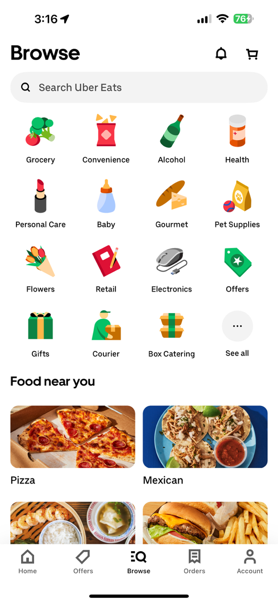

Since both have a search function on the bottom nav bar we should compare how they differ and how they are similar. Uber Eats uses the same menu that was available on the home screen with the same search bar. It also has categories and pictures which would make it more accessible and is a match between system and the real world. Meanwhile the Wolt app uses a search bar and then a collage of categories to choose from. They don’t seem very organized which could mean they are sorted by popularity, but it can be hard for users to choose something if they don’t know what they wanted already. It also has my recent orders which can give me more options to things I might want to order. Uber Eats uses a grid layout while Wolt uses a mesh layout.

Continuing if I were to order pizza, I clicked on the pizza button on both screens, and we are met with a very similar set up. On the Uber Eats side they decided to use a stacked layout to convey information while Wolt uses a horizontal layout. Both use images on the left- hand side and filters on top to sort anything you may want. They also both have the same information including delivery fee, expected delivery time, and rating, while Wolt also has distance from you. This uses the visibility of system status principle showing that the delivery time is flexible, and the app is providing real time updates.

The underlying themes of what I have found is that both apps focus on convenience and usability. They both strive to be simple and easy to use so that user wants to make a purchase. They also both use visual hierarchy to make sure that anything the user would want to find they can find easily.

**Recommendations and Design Implications**

Some recommendations that I would suggest would be to make the browse page on the

Uber Eats app more customizable to the user using it. Maybe something like based on your

previous orders, or a previous orders button within the 4x4 grid. This would make it easy to reorder food and make the app more personable to the user. An app like this is hard to find any improvements for since there is so much R&D put into a multibillion-dollar app, but nothing is perfect.

For Wolt, I would suggest something like as a 1 tap reorder button instead of just my recent orders. I would also make a clear all filters. It seems like this app has a lot more minor

issues compared to the Uber Eats app. I think this is most likely due to the fact they both have lots of experience in UX design, but maybe Wolt doesn’t have enough customer data on what to improve.

I didn’t encounter too many issues other than the fact that when I was making this project the pizza places were closed in Cyprus, so I had to wait until morning to submit a photo. I

compared it to a convenience store that was open to compare what information it had

compared to Uber Eats. I then had to update the picture.